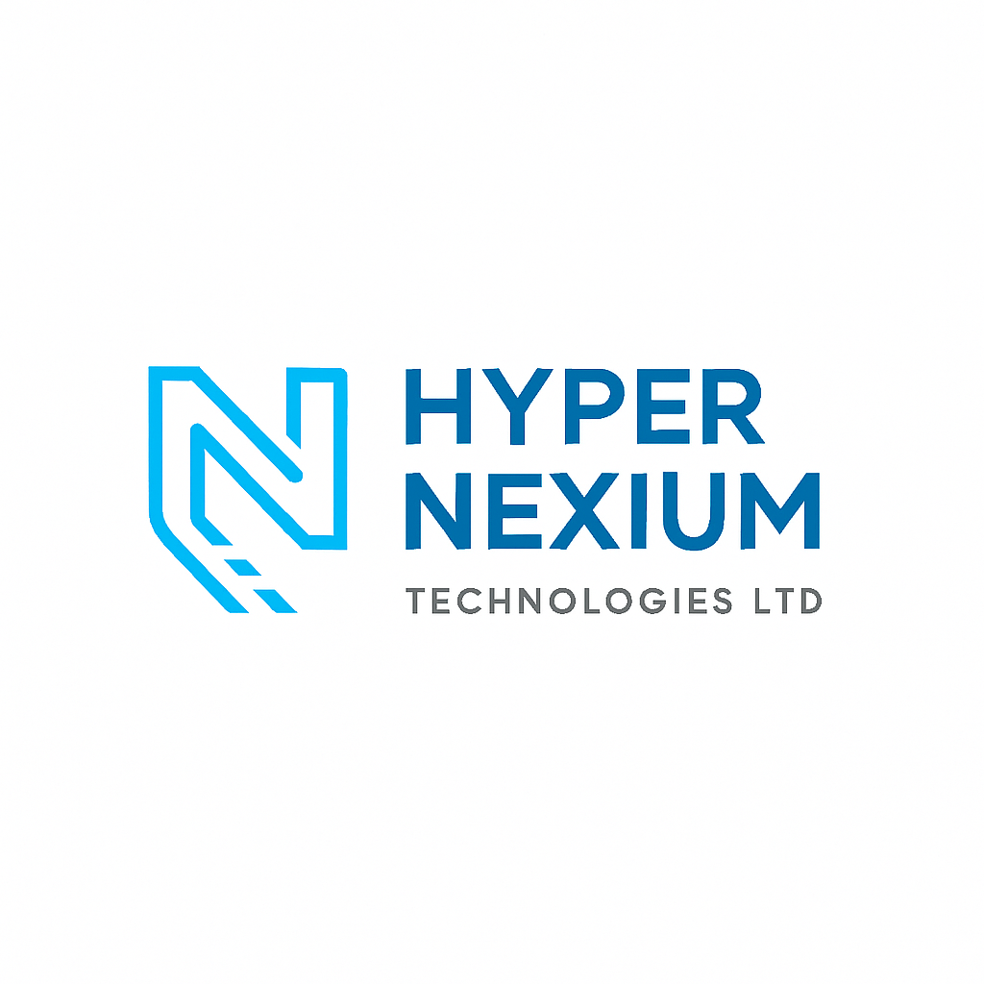**Corporate Company Profile**

**Company Name:** Hyper Nexium Technologies Ltd  
**Tagline:** *Powering Smart Enterprises Beyond Limits.*

**About Us**

Hyper Nexium Technologies Ltd is a forward-thinking, technology-driven company specializing in advanced IT solutions designed to empower smart enterprises with hyper-efficient and scalable technologies. Our goal is to bridge the digital divide by offering world-class services that drive innovation, efficiency, and security in the modern enterprise landscape.

Founded with a passion for cutting-edge technology and a commitment to delivering high-impact solutions, Hyper Nexium Technologies Ltd has become a trusted partner for businesses looking to embrace transformation with speed, intelligence, and confidence.

**Mission Statement**

To empower businesses with intelligent, secure, and future-ready technology solutions that enable them to scale, adapt, and thrive in an ever-evolving digital world.

**Vision Statement**

To be the preferred technology partner across Africa and beyond, recognized for driving smart enterprise growth through innovative, hyper-efficient solutions.

**Core Values**

* **Innovation:** We continuously explore new technologies to provide cutting-edge solutions.
* **Integrity:** We uphold honesty, transparency, and strong ethical principles in every engagement.
* **Customer Focus:** We prioritize our clients’ needs and deliver personalized experiences that exceed expectations.
* **Excellence:** We strive for superior quality in everything we do.
* **Agility:** We adapt quickly to changes, delivering flexible and scalable solutions.
* **Collaboration:** We foster partnerships and teamwork to drive collective success.

**Our Core Services**

**1. Cybersecurity**

Protecting digital assets with proactive and multi-layered security frameworks that defend against modern cyber threats.

**2. Backup and Recovery**

Enterprise-grade data backup and disaster recovery solutions that ensure business continuity and data integrity.

**3. Digital Infrastructure**

Designing, deploying, and managing scalable infrastructure that supports cloud, hybrid, and on-premises environments.

**4. Network Modernization**

Upgrading traditional networks with smart, agile, and secure networking solutions to meet current and future demands.

**5. Surveillance Security Systems**

Advanced video surveillance and monitoring systems tailored for enterprise security, leveraging AI and IoT integrations.

**6. IT Training**

Capacity-building programs and technical training for teams, aimed at upskilling employees in key IT domains.

**Our Strategic Partners**

We are proud to collaborate with some of the world’s leading technology brands to deliver unmatched solutions to our clients:

* **Kaspersky**
* **Dell Technologies**
* **Cisco**
* **Huawei**
* **Hikvision**
* **Microsoft**
* **VMware**
* **Veeam**
* **Veritas**
* **Nutanix**
* **D-Link**
* **Palo Alto Networks**
* **Symantec**
* **Avaya**
* **HP**
* **Fortinet**
* **Sophos**
* **Lenovo**

**Why Choose Hyper Nexium Technologies Ltd?**

* **Client-Centric Solutions:** Tailored services that align with your business goals.
* **Certified Experts:** A team of trained and certified professionals across multiple domains.
* **Innovative Technology Stack:** We leverage top-tier technologies and platforms to deliver high-performance solutions.
* **Agile Execution:** Speed and precision in service delivery with a focus on measurable business outcomes.
* **End-to-End Support:** From consultation to deployment and after-sales support.

**Contact Us**

**Address:** [Insert company address]  
**Phone:** [Insert phone number]  
**Email:** [Insert email address]  
**Website:** [Insert website URL]

**Hyper Nexium Technologies Ltd**  
*Powering Smart Enterprises Beyond Limits.*